File Distribution Service

For Backend - ASP.NET Core 6.0 web api
For Database - Postgres
- Use minimal design
  - Program.cs contains get and post methods.
  - No controllers architecture preferred

- Upload / download small (MB) to large files (> 1GB < 2GB)
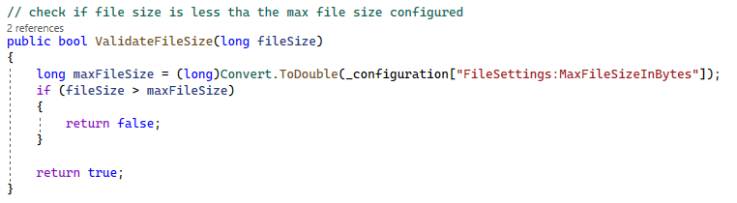

- Enable / disable uploading / downloading types of files by declaring it in configuration file
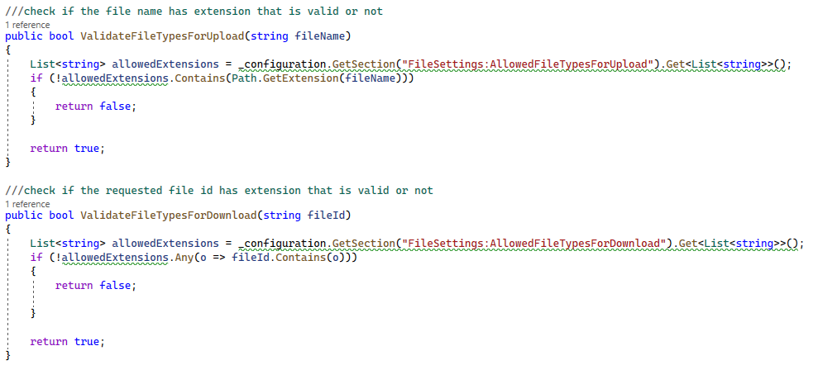

- Handle business logic filtering (file size limits, types of files) in custom middleware
  - A FileValidation.cs middleware is defined which validates the file size, type, download time, file exists and file id

- Allow downloading of files only for a particular time period of the day (e.g. 8:00 AM to 2:00 PM)
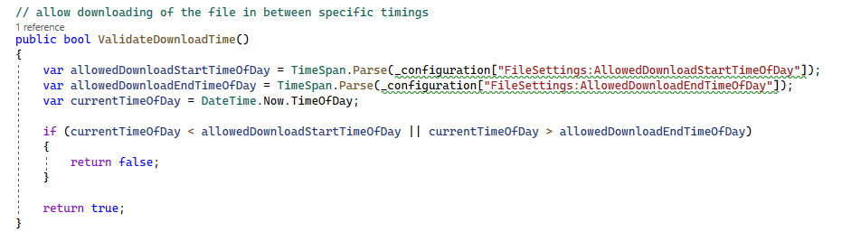

- Storing the uploaded files in a designated folder, details of which are declared in the configuration file
  - Below configuration is used for performing file operations
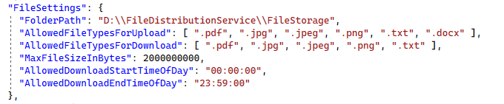

- Apply best practice security principles
  - For securing, an apikey authentication is used at middleware level for all apis. HTTP request header must contain a key:value pair i.e “x-api-key: sada238238asdkkedm2349949565949”

- Apply best practice structured logging
  - Serilog is used with rollingInterval = “Day”, retainedFileCountLimit = 10 and rollOnFileSizeLimit =true.
  - The logger instance logs both information and errors

- Handle happy and unhappy path cases with examples
  - Handling happy cases:
    - Setting Response Model instance’s StatusCode and StatusMessage of where file validations failed.
    - Setting context.Response.StatusCode to Status404NotFound, Status204NoContent or Status500InternalServerError where expected input is not provided in the HTTP request
    - For each api one sample test case has been added in the Tests NUnit project.

  - Handling unhappy cases:
    - Wrapping database insertion/selection code within try block and caught that exception in the catch block. This exception gets thrown to the GlobalException.cs middleware where is caught as custom exception i.e. DatabaseException()
    - Inside FileValidation.cs middleware if any filevalidation error occurs then it gets caught in the catch block. This exception gets thrown to the GlobalException.cs middleware where is caught as custom exception i.e. FileValidationException()

- Store the information in a database that can provide data to a dashboard API
  - Created an API "/files/dashboarddata" which takes zero to four query parameters i.e filename, uploadedFrom, uploadedTo, lastDownloadedFrom and lastDownloadedTo in the HTTP request.
  - A GET method which returns all/conditional data in the JSON format via GetAllFilesDetails() defined in FileService.cs
  - Response sample:
